2009 City of Slaton Citizen Survey
Your City Logo Here
You are randomly selected to help the City better understand the needs and priorities of our community. Your opinion does count and is extremely valuable in shaping the future of our community. You do not need to identify yourself because responses will be published in an aggregate form. Your participation is voluntary Thank you in advance for your time and show of concern for our community.
Please return this survey by March 4, 2009  Directions: Please circle the most appropriate response or follow the directions given in the question.  How satisfied are you with each of the following conditions or services  provided by the City? | 5= Very Satisfied | 4= Satisfied | 3= Neutral | 2= Unsatisfied | 1= Very Unsatisfied | 0= No Opinion
- City’s efforts in attracting economic development (businesses, industries, retailers, etc.) | 5 | 4 | 3 | 2 | 1 | 0
- Value of the City services you receive versus the City Taxes you pay | 5 | 4 | 3 | 2 | 1 | 0
- Quality of life in _____________ | 5 | 4 | 3 | 2 | 1 | 0
- Usefulness of information you receive from the City of __________________ | 5 | 4 | 3 | 2 | 1 | 0
- Storm-water Drainage in your neighborhood | 5 | 4 | 3 | 2 | 1 | 0
- Water Quality (taste) | 5 | 4 | 3 | 2 | 1 | 0
- Water Pressure within your neighborhood | 5 | 4 | 3 | 2 | 1 | 0
- Wastewater Services in your neighborhood | 5 | 4 | 3 | 2 | 1 | 0
- Street maintenance in your neighborhood | 5 | 4 | 3 | 2 | 1 | 0
- Overall condition of roads in the City | 5 | 4 | 3 | 2 | 1 | 0
- Pedestrian mobility in the City | 5 | 4 | 3 | 2 | 1 | 0
- Traffic Regulation Enforcement | 5 | 4 | 3 | 2 | 1 | 0
- Traffic Flow/mobility | 5 | 4 | 3 | 2 | 1 | 0
- Right of Way maintenance in your neighborhood | 5 | 4 | 3 | 2 | 1 | 0
- Utility Billing Customer Service | 5 | 4 | 3 | 2 | 1 | 0
- Overall quality of the City’s customer service | 5 | 4 | 3 | 2 | 1 | 0
- Trash collection services | 5 | 4 | 3 | 2 | 1 | 0
- Recycling Program | 5 | 4 | 3 | 2 | 1 | 0
- Safety within your neighborhood | 5 | 4 | 3 | 2 | 1 | 0
- Building Inspections/Permits | 5 | 4 | 3 | 2 | 1 | 0
- Code Enforcement - weeds, junk vehicles, etc. | 5 | 4 | 3 | 2 | 1 | 0
- Fire Services | 5 | 4 | 3 | 2 | 1 | 0
- Ambulance Services | 5 | 4 | 3 | 2 | 1 | 0
- Animal Control | 5 | 4 | 3 | 2 | 1 | 0
- Parks & Trails | 5 | 4 | 3 | 2 | 1 | 0
- Parks & Trail Maintenance | 5 | 4 | 3 | 2 | 1 | 0
- Recreational Programs | 5 | 4 | 3 | 2 | 1 | 0

28. If you have contacted the City within the last 12 months, what was the purpose of the contact? Circle all that apply.
a. Utility Bill f. Recycling j. Park Rental/Rec. Programs
b. Water or Wastewater Utilities g. Animal Control k. Permits
c. Streets h. Police l. Other
d. Drainage i. Code Enforcement m. No Contact
e. Trash Collection

29. What would be the best way for you to receive information about the City of _______? Please choose only one option.
a. Local Newspaper b. City Newsletter c. City Website d. E-mail
e. City Cable Channel f. Local radio g. Other _________
30. Which of the following programs would you support to be included on utility bills for citizens to make donations in support of the programs? Please circle up to four (4) responses.
a. Billing Assistance for other families b. Animal Shelter c. ____________
d. Keep _________ Beautiful e. _____________ f. Parks Projects
g. Parks & Rec. Summer Camp Scholarships h. City Projects i. None
31. Please rank your top three priorities for the _________ community (Limit your responses to a maximum of three words per item).
1. _______________________ 2. ________________________ 3. ______________________
32. Two percent of the total sales tax you pay is the City’s sales tax. How would you like this money to be spent?
Suppose you have one dollar in hand. Distribute this dollar among the following options.
- Manufacturing and Industrial Development | ¢
- Property Tax Reduction | ¢
- Infrastructure (water, wastewater, street) improvements to develop new and expanded business | ¢
- Affordable Housing | ¢
- Street Maintenance (on existing streets) | ¢
- Public Parks and Sports Venues | ¢
TOTAL | 100 ¢

33. How would you like to see the future development of downtown? Please choose as many as needed.
a. Retail b. Office c. Restaurants/Entertainment d. Residential
e. Green Space/Parks f. City Facilities g. Other_______________

- If the City offered a daily bus transit service from one stop in __________ to _________ each morning and evening for a small fee, would you use it to get to and from work? | Yes | No
- Would you like to receive e-mail notifications about City services, meetings, events and publications? | Yes | No
- If the City offered free wireless internet in public parks and facilities, would you use the service? | Yes | No
- If the City provided High Speed Wireless Internet, will you subscribe to it for a monthly fee? | Yes | No
- Would you use a City of ___________ owned and operated Library? | Yes | No
- Would you be in favor of a bond election to issue debt for Parks Improvements? | Yes | No
- Are you registered to vote? | Yes | No
- If you are a registered voter, did you vote in the last General Election? | Yes | No
- Would you support a monthly stipend for City Council members? | Yes | No
- If you do support a monthly stipend for City Council members, the monthly stipend should be $_________ per month.

How important are the following services to you? | 3= Very Important | 2= Important | 1= Not Important | 0= No Opinion
- Increasing employment opportunities | 3 | 2 | 1 | 0
- Redeveloping older areas of the City | 3 | 2 | 1 | 0
- Expanding retail opportunities | 3 | 2 | 1 | 0
- Development of _______________ | 3 | 2 | 1 | 0
- Downtown Development | 3 | 2 | 1 | 0
- Roadway Improvements | 3 | 2 | 1 | 0
- Drainage Improvements | 3 | 2 | 1 | 0
- Increasing Sidewalks & Trails | 3 | 2 | 1 | 0
- Enhancing transportation options | 3 | 2 | 1 | 0
- Citizen Police Academy | 3 | 2 | 1 | 0
- Neighborhood Watch Program | 3 | 2 | 1 | 0
- Crime Prevention Programs | 3 | 2 | 1 | 0
- Public Library | 3 | 2 | 1 | 0
- Public Pool | 3 | 2 | 1 | 0
- New City Hall | 3 | 2 | 1 | 0
- New ______________ | 3 | 2 | 1 | 0
- Community Center | 3 | 2 | 1 | 0
- Regional Park | 3 | 2 | 1 | 0
- Youth Recreation Programs | 3 | 2 | 1 | 0
- Teen Recreation Programs | 3 | 2 | 1 | 0
- Senior Programs | 3 | 2 | 1 | 0
- Fitness/Aerobic Fitness Programs | 3 | 2 | 1 | 0
- Hike and Bike Trails | 3 | 2 | 1 | 0
- Skate Park | 3 | 2 | 1 | 0
- Recreation Center | 3 | 2 | 1 | 0
- Developing leisure activities (parks, recreation, library, etc) | 3 | 2 | 1 | 0

70. How long have you lived in __________? _______ years.

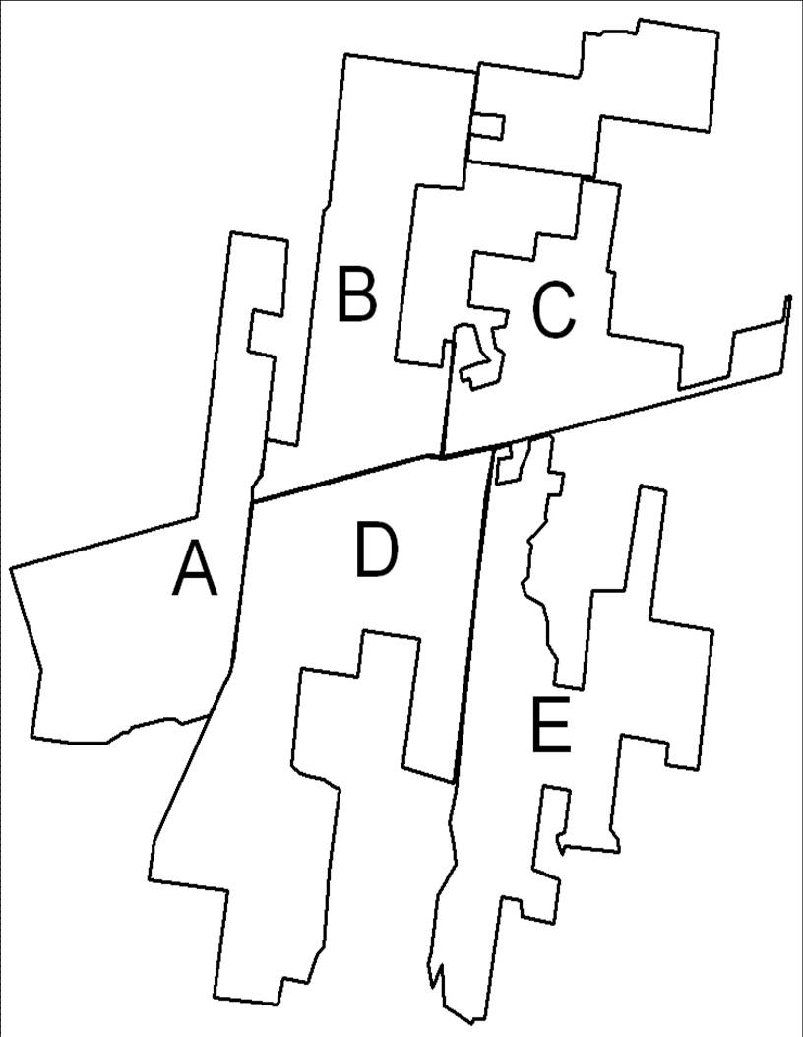
71. In which area do you live? Please, see the graph. [example]
A West of FM 685
B North of Hwy 79, Between FM 685 and FM 1660
C North of Hwy 79, East of FM 1660
D South of Hwy 79, Between FM 685 and FM 1660
E South of Hwy 79, East of FM 1660

72. Do you rent or own your home? a. Own b. Rent c. Rent free situation

73. Which of the following options best describes your age category?
a. 18-25 b. 26-40 c. 41-50 d. 51-65 e. Over 65

74. Which of the following best describes your ethnicity/race?
a. African Amer. b. Hispanic c. Caucasian/Anglo d. Asian
e. Native Amer. f. Other

75. Which of the following options best describes your total annual household income?
a. Less than $25,000 b. $25,000 – $49,999 c. $50,000 - $74,999 d. $75,000 - $99,999
e. $100,000 - $124,999 f. $125,000 - $149,999 g. Over $150,000

76. Which of the following options best describes your education level?
a. Less than High School b. High School c. Some College d. College Degree

77. How many adults (18 or older) live in your household? ____________

78. How many children (less than 18) live in your household? ______________

Comments:_______________________________________________________________________________________________________________________________________________________________________________________________________________________________________________________________________________

